Cancer: Thriving and Surviving

The Chronic Disease Self-Management Program of Stanford University
Sessions include: ✓ Techniques for dealing with frustration, fatigue, pain, isolation, sleep, & uncertainty

Appropriate exercise to regain and maintain flexibility and endurance
- Treatment decisions and complementary therapies
- Communication techniques with family, friends and health professionals
- Nutrition
- Setting priorities
- Relationships
This FREE 6-week workshop will be offered on

XXXXXXXX

Community Partner Name
Address

For additional information and to register for this six week program,
please call XXX-XXX-XXXX or register on line at:

All participants will receive a copy of the companion book, Living a Healthy Life with Chronic Conditions, 4th Edition, and a CD, Mind and Body

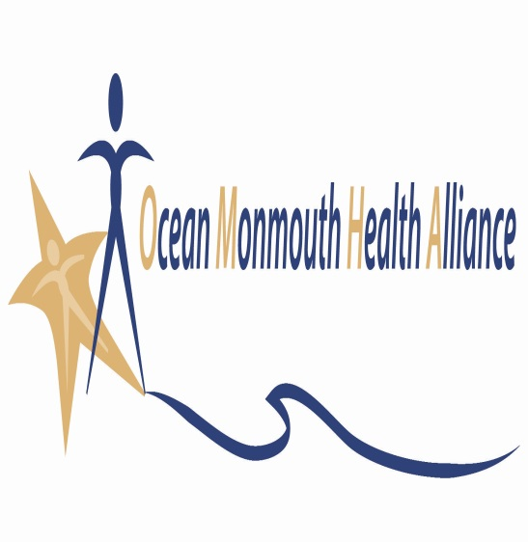
Your organization’s logo can be added to this.

Sponsored by: Ocean Monmouth Health Alliance, Social Communities Action Network (SCAN). Ocean Monmouth Health Alliance is a regional chronic disease prevention coalition funded by the Office of Cancer Control and Prevention of the NJ Department of Health.

For more information on Comprehensive Cancer Control in NJ, visit www.njcancer.gov

